**Practice-1**

**Aim: WAP to create a class to read and add two distance. (e.g. 8 feet 16 inch + 4 feet 14 inch = 14 feet 6 inch)**

**Promgram:**

#include<iostream>

using namespace std;

class Distance

{

public:

int feet;

int inch;

};

int main()

{

Distance d1,d2,total;

cout << "enter the first distance :"<<endl;

cout << "enter the feet : ";

cin >> d1.feet;

cout << "enter the inch : ";

cin >> d1.inch;

cout << "enter the second distance :"<<endl;

cout << "enter the feet : ";

cin >> d2.feet;

cout << "enter the inch : ";

cin >> d2.inch;

total.feet=d1.feet+d2.feet;

total.inch=d1.inch+d2.inch;

total.feet=total.feet + (total.inch/12);

total.inch=total.inch % 12;

cout << "total distance is " << total.feet << " feet and " <<total.inch <<" inches " <<endl;

return 0;

}

**Output:**

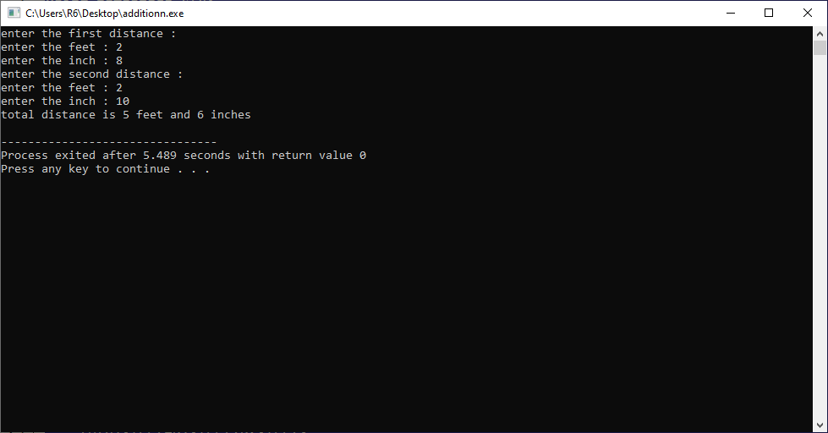

**Practice-2**

**Aim:WAP to create a class to read and add two times.**

**Promgram:**

#include<iostream>

using namespace std;

class Time

{

public :

int hours;

int minutes;

int seconds;

};

int main()

{

Time t1,t2,total,seconds;

cout << "enter first time" <<endl;

cout << "enter hours :"; cin>>t1.hours;

cout << "enter minutes :"; cin>>t1.minutes;

cout << "enter seconds :"; cin>>t1.seconds;

cout << "enter second time" <<endl;

cout << "enter hours :"; cin>>t2.hours;

cout << "enter minutes :"; cin>>t2.minutes;

cout << "enter seconds :"; cin>>t2.seconds;

total.seconds=t1.seconds+t2.seconds;

total.minutes=t1.minutes+t2.minutes + total.seconds/60;

total.hours=t1.hours+t2.hours + total.minutes/60;

total.seconds=total.seconds%60;

total.minutes=total.minutes%60;

cout <<endl <<"total time is =>" <<total.hours <<":"<<total.minutes<<":"<<total.seconds <<endl;

}

**Output:**

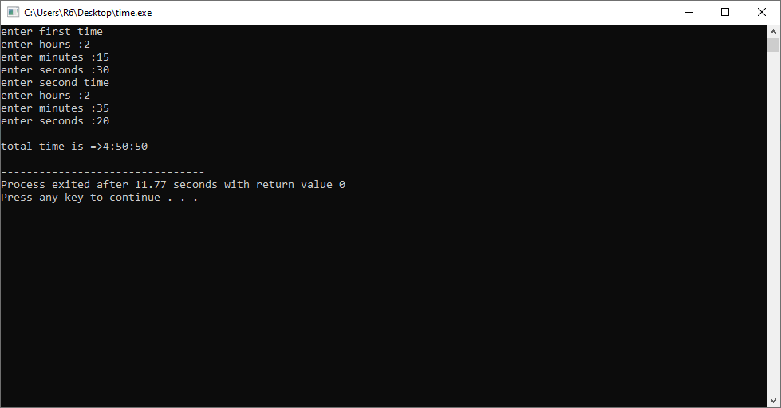

**Practice-3**

**Aim:WAP to create class to read time in seconds and convert into time in (HH:MM:SS) format.**

**Promgram:**

#include<iostream>

using namespace std;

class Converter

{

public:

int hours;

int minutes;

int seconds;

};

int main()

{

Converter t1;

cout << "Enter a second :- "; cin >> t1.seconds;

t1.hours = (t1.seconds/60)/60;

t1.minutes = (t1.seconds/60)%60;

t1.seconds = t1.seconds%60;

cout <<"time in hh:mm:ss formate is =>"<< t1.hours << " : " << t1.minutes << " : " << t1.seconds << endl;

return 0;

}

**Output:**

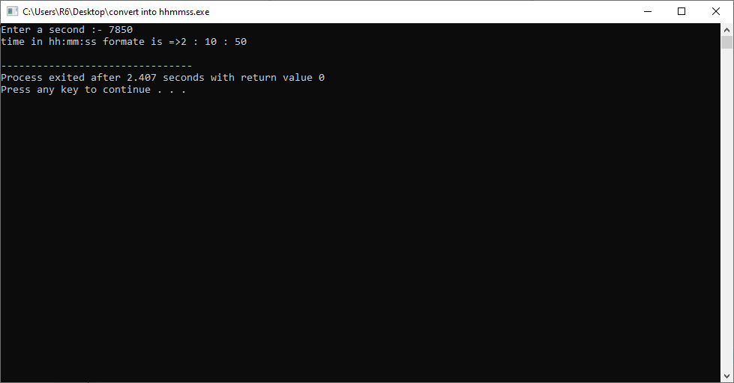

**Practice-4**

**Aim:WAP to create a class which Read and Print House details along with Room details.**

**Promgram:**

#include<iostream>

using namespace std;

class house

{

public:

int house_number;

char house_name[100];

int room;

int hall;

int bathroom;

int kitchen;

};

class Room

{

public :

int bed;

int fan;

int ac;

int pc;

char pet_name[100];

int picture;

};

int main()

{

house p1;

Room p2;

cout <<"enter all house detail and room details ::::"<<endl<<endl;

cout << "enter house number : "; cin >> p1.house_number;

cout << "enter house name : "; cin >> p1.house_name;

cout << "enter how many rooms in house : "; cin >> p1.room;

cout << "enter how many kitchen in house : "; cin >> p1.kitchen;

cout << "enter how many hall in house : "; cin >> p1.hall;

cout << "enter how many bathroom in house : "; cin >> p1.bathroom;

cout <<endl<<endl;

cout << "house number is : " <<p1.house_number <<endl << "house name : "<<p1.house_name <<endl;

cout << " room :" <<endl<< p1.room << " kitchen :" << p1.kitchen <<endl<< " hall :" <<p1.hall<<endl

<< " bathrooms :" <<p1.bathroom <<endl;

cout << "===================================================================="<<endl;

cout << "enter how many bed : " ; cin >> p2.bed;

cout << "enter how many fan : " ; cin >> p2.fan;

cout << "enter how many ac : " ; cin >> p2.ac;

cout << "enter how many pc : " ; cin >> p2.pc;

cout << "enter pet name : " ; cin >> p2.pet_name;

cout << "enter how many pictures : " ;cin >> p2.picture;

cout <<endl<<endl;

cout << "number of beds is : " << p2.bed <<endl <<"number of fans : "<<p2.fan << endl <<"number of ac : "

<<p2.ac<<endl<<"number of pc : "<<p2.pc<<endl<<"pets name are : "<<p2.pet_name <<endl <<"number of picture in wall : "

<<p2.picture <<endl;

}

**Output:**

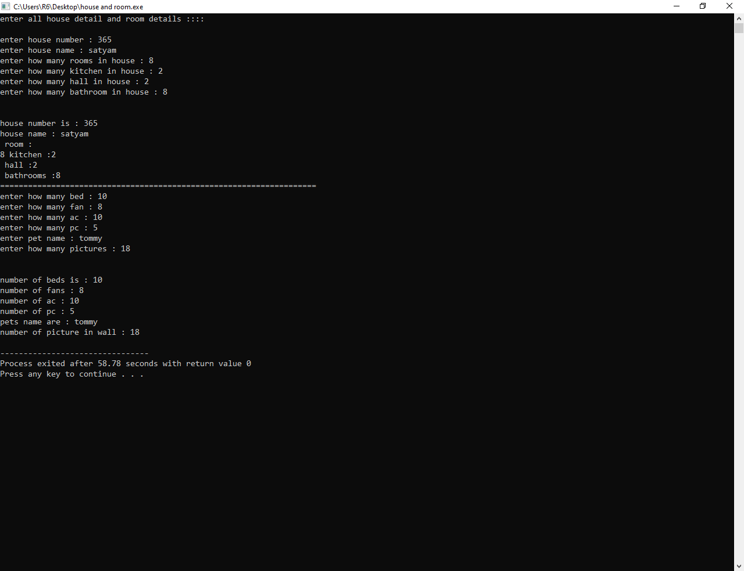

**Practice-5**

**Aim: WAP which illustrates the use of public and private access modifiers.**

**Promgram:**

#include<iostream>

using namespace std;

class car

{

private :

int id;//doesnt run of this is private

public :

char color[100];//run because this is public

char model[100];

};

int main()

{

car c1;

cout << "enter car color : "; cin >>c1.color;

cout << "enter car model : "; cin >>c1.model;

cout <<"color id =>"<<c1.color<<endl<<"model is =>"<<c1.model <<endl;

return 0;

}

**Output:**

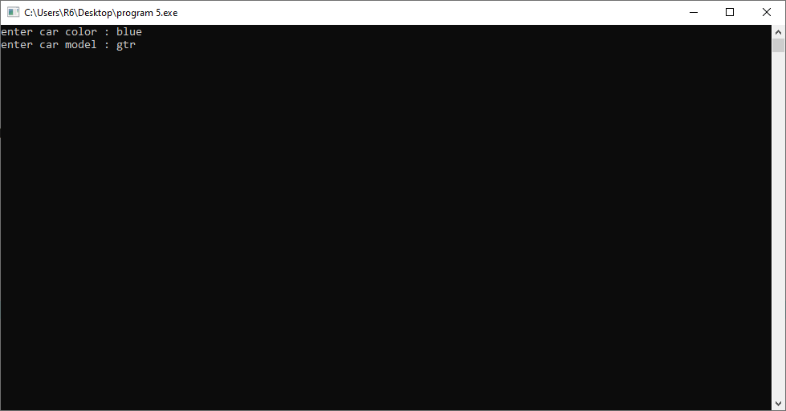

**Practice-6**

**Aim: WAP to generate cube of given 5 numbers and make an array of that generated cubes.**

**Promgram:**

#include<iostream>

#include<math.h>

using namespace std;

int main()

{

int a[5],cube,i;

cout << "enter 5 elements in array:"<< endl ;

for(i=1; i<=5; i++)

{

cin >> a[i];

}

cout << "cube of array :"<<endl ;

for(i=1; i<=5; i++)

{

cube=a[i]*a[i]*a[i];

cout << cube << endl;

}

return 0;

}

**Output:**

